HUMANA & VETERANS OF FOREIGN WARS POST 2702
ARE
UNITING TO COMBAT HUNGER

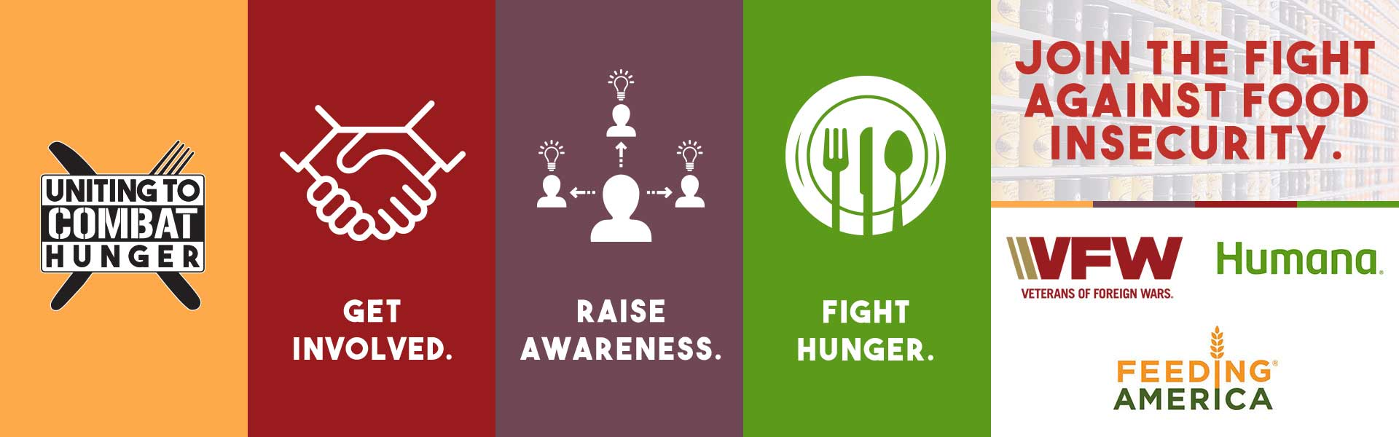

The VFW, Humana, and Feeding America currently have a $1 million dollar Goal for 2021. Our post is supporting our Local Feeding America Food Bank, which is the Food Bank of North Alabama, located at 2000 Vernon Ave SW, Huntsville, AL, 35805. Every dollar donated helps provide at least 10 meals. Due to the Pandemic and the economic fallout from the Pandemic it has been difficult for Veterans posts to do as much for the community. With the help from Humana and Feeding America, we have been given the opportunity to Support the community and our local Veterans. One in eight people are experiencing food insecurities right now and one in four Veterans are also affected by this. 22 Veterans commit suicide each day. I am certain having to deal with where your next meal comes from has a big part to play in this. No one should have to experience or endure these insecurities. Let us start uniting to Combat Hunger in our Communities today. Come join us at one of our events or contact the VFW Post 2702 Quartermaster/Adjutant, April Thomas at phone # 256-690-1645 or by email at vfw.2702.adjutant@gmail.com today.
Humana and our Post will be set up at the Redstone Harley Davidson, located at 15100 State Hwy 20 W, Madison, AL 35756, on 7 August from 1000 – 1400 hours.
Our Post will also be participating and setting up at the Whistle Stop BBQ contest on the 13th & 14th of August. This event will take place at the Huntsville Depot Museum, located at 320 Church St NW, Huntsville, AL 35801.
We appreciate your Call to Action "Uniting to Combat Hunger 2021" in the Community. Thank you in advance for your participation. A Go Fund me account has also been set up at the following: https://gofund.me/94d827b9 and on the VFW Post 2702 Website http://vfw2702.org.

